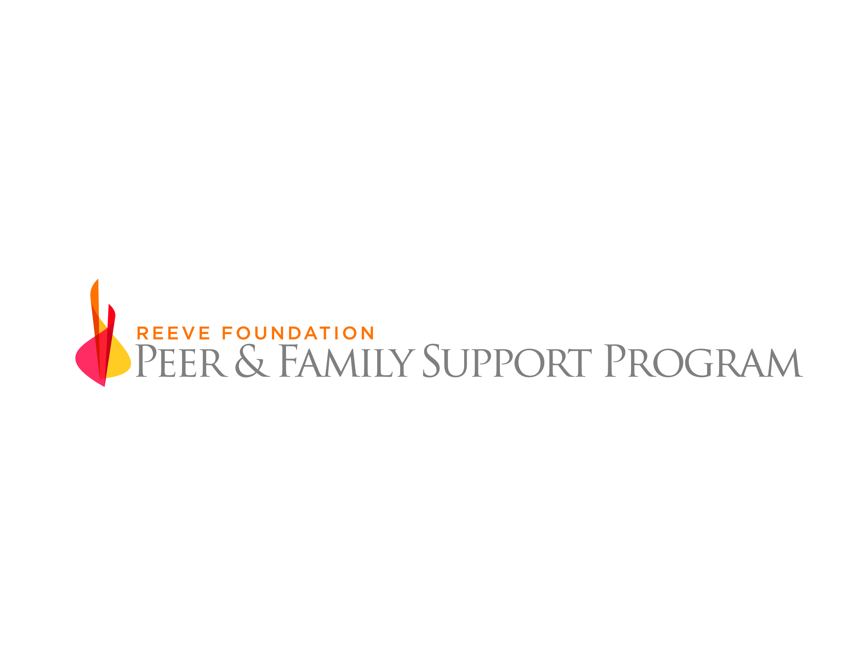

Referring Partner Agreement

Introduction

The Reeve Foundation (RF) is a nationally recognized leader within the paralyzed/spinal cord injured (SCI) community, dedicated to curing spinal cord injury through expert funding of innovative research and improving the quality of life for people living with paralysis through grants, information and advocacy. The Reeve Foundation’s Paralysis Resource Center (PRC) promotes the health, well-being and independence of people living with a spinal cord injury, mobility impairment, or paralysis by providing comprehensive information, resources and referral services.

The Reeve Foundation Peer & Family Support Program (PFSP) is a national peer-to-peer mentoring program. Its mission is to provide critical emotional support and information on local and national resources to people living with paralysis, their families and caregivers. A peer mentor is a positive role model who utilizes his/her own personal experiences and knowledge of life with paralysis to provide support and guidance, answer questions and empower those impacted by paralysis.

Peer mentoring is arguably the most direct and beneficial tactic to assist those living with paralysis and their families and caregivers. The assistance and guidance from someone who is thriving with the same or similar injury does much to calm and focus the newly injured as well as the person transitioning through the stages of life with paralysis.

The need for those living with paralysis to have the support necessary to achieve goals such as transitioning home from rehab, returning to work or school, and living independently may never be greater. Family members also need support in caring for a loved one who is paralyzed, navigating the emotions of caregiving and coping with its responsibilities. We know that hospital stays for the newly injured have been tragically reduced, and services at local and state levels have also been reduced or nearly vanished. There is a significant void in service and support to those that live with paralysis, and this void will most likely continue to grow. We believe a national peer mentoring program helps fill that void.

No one hospital, foundation or mentor program can fill the national void alone. We believe working with existing programs is one way to accomplish the goal of a true national mentoring program, and we recognize and appreciate the fine work already being done at organizations and institutions across the country. The Reeve Foundation hopes to attract and work with these facilities as we connect-the-dots of peer programs across the country and continue to create a network covering the entire United States.

PFSP Primary Goals

- Provide support and information to people living with paralysis, their family members and caregivers so that they can achieve and maintain independence and improve their quality of life.
- Increase the amount of mentoring occurring across the country.
- Increase the utilization of trained peer mentors.
- Utilize peer mentors who have the powerful combination of their own life experiences and a knowledge of and access to information and resources at the national and local levels.
- Collect quantifiable data and anecdotal information to clearly demonstrate the importance of peer mentoring to the paralyzed community.
- Provide peer mentors with a standardized baseline of training to ensure a level of consistency across the country.
- Provide ongoing education and training materials to increase mentor knowledge and support.

Benefits for a Referring Partner

- Offer an additional service to partners for their patients, including outpatients, to augment the Referring Partner’s current program offerings and services.
- Access to a set of peer mentors that have gone through a comprehensive training and certification process and a federal background check.
- A standardized training curriculum developed and managed by the RF. The content of the training will be reviewed periodically and updated based on feedback from peer mentors, peers and partners. Partner input is desired and needed to achieve a “best in class” program.
- Be able to extend the Referring Partner’s reach outside of its current coverage area and identify new potential patients.
- Partner with a well-known and respected foundation and national brand within the paralyzed community.
- Participate in proactive outreach to promote peer mentoring.
- A program coordinator to manage the administrative and management functions of the program at no expense to the Referring Partner.
- Access to the most diverse national peer mentor pool, allowing for the most appropriate peer/mentor matches for Referring Partner peers.
- The promotion of XXXXXXXXXX throughout the state and nation as a Reeve Foundation partner.
- Access to the PRC Information Specialists and an evaluation and surveillance process to assess peer satisfaction and identify emerging needs.
- The Referring Partner will be provided with general statistics about their referrals upon request.

The Referring Partner agrees to

- Accept the PFSP’s mission and stated goals.
- Provide a staff member to act as a liaison with the PFSP Program Coordinator.

Peers

- The Referring Partner agrees to assist in identifying and recruiting peers. A peer is defined as a person who is living with paralysis or their family members and caregivers.
- The Referring Partner agrees to make peer referrals. A referral is defined as basic contact information for a peer, such as name, email, and phone.
- The Referring Partner agrees to make a concerted effort to recruit XX peers on an ongoing annual basis.
- Referring Partner staff or liaison will facilitate connecting the PFSP Program Coordinator with the potential peer.

Promotion

- The Referring Partner agrees to, but is not limited to:
  - Post flyers, display materials, and include peer mentoring information in discharge paperwork, etc.
  - Send email blasts to the Referring Partner’s various email lists.
  - Publish at least 1 “Peer” story annually in the Referring Partner’s publication(s).
- Make marketing, social media and community outreach staff available to meet and discuss marketing opportunities and peer recruitment efforts.
- Agree to 1 in-service presentation per year.

The PFSP agrees to

- Provide peer mentors to match with the Referring Partner’s peers using our matching criteria.
- Match peers with a local peer mentor whenever possible but utilize remote mentoring when appropriate to make the best match.
- Manage all peer relationships and referrals.
- Provide email, poster and social media templates and content for marketing and social media staff.
- Share statistical info related to the program activity.

Referring Partner Agreement

The partnership does not preclude Referring Partner from working with The Reeve Foundation in other capacities.

Either party may terminate this partnership at any time with or without cause, and with a 30-day written notice.

Effective Date

This Partnership Agreement shall come into effect upon final signature.

Signatures

________________________________________ _______________________________________
Bill Cawley XXXXX
Director, Peer & Family Support
Program XXXXX
The Christopher & Dana Reeve Foundation XXXXXXXX

Date: ________________________________ Date: ________________________________

