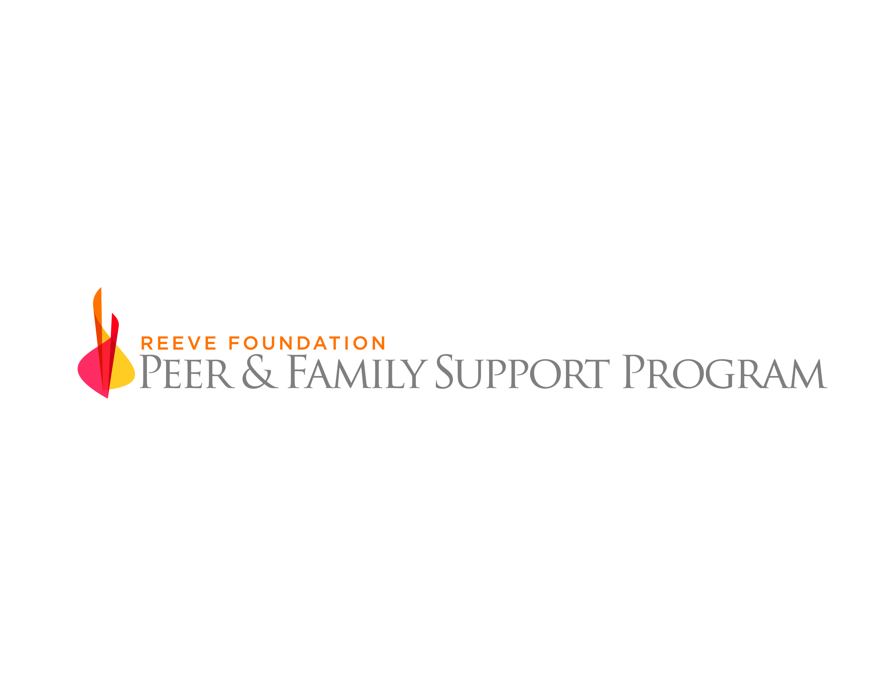

Agreement between The Christopher and Dana Reeve Foundation
and XXXXXXXXXX, an organization wishing to partner in support of peer mentoring

Introduction

The Reeve Foundation (RF) is a nationally recognized leader within the paralyzed/spinal cord injured (SCI) community, dedicated to curing spinal cord injury through expert funding of innovative research and improving the quality of life for people living with paralysis through grants, information and advocacy. The Reeve Foundation’s Paralysis Resource Center (PRC) promotes the health, well-being and independence of people living with a spinal cord injury, mobility impairment, or paralysis by providing comprehensive information, resources and referral services.

The Reeve Foundation Peer & Family Support Program (PFSP) is a national peer-to-peer mentoring program. Its mission is to provide critical emotional support and information on local and national resources to people living with paralysis, their families and caregivers. A peer mentor is a positive role model who utilizes his/her own personal experiences and knowledge of life with paralysis to provide support and guidance, answer questions and empower those impacted by paralysis.

Peer mentoring is arguably the most direct and beneficial tactic to assist those living with paralysis and their families and caregivers. The assistance and guidance from someone who is thriving with the same or similar injury does much to calm and focus the newly injured as well as the person transitioning through the stages of life with paralysis.

The need for those living with paralysis to have the support necessary to achieve goals such as transitioning home from rehab, returning to work or school, and living independently may never be greater. Family members also need support in caring for a loved one who is paralyzed, navigating the emotions of caregiving and coping with its responsibilities. We know that hospital stays for the newly injured have been tragically reduced, and services at local and state levels have also been reduced or nearly vanished. There is a significant void in service and support to those that live with paralysis, and this void will most likely continue to grow. We believe a national peer mentoring program helps fill that void.

No one hospital, foundation or mentoring program can fill the national void alone. We believe working with existing programs is one way to accomplish the goal of a true national mentoring program, and we recognize and appreciate the fine work already being done at organizations and institutions across the country. The Reeve Foundation hopes to attract and work with these facilities as we connect-the-dots of peer programs across the country and continue to create a network covering the entire United States.

PFSP Primary Goals

- Provide support and information to people living with paralysis, their family members and caregivers so that they can achieve and maintain independence and improve their quality of life.
- Increase the amount of mentoring occurring across the country.
- Increase the utilization of trained peer mentors.
- Utilize peer mentors who have the powerful combination of their own life experiences and a knowledge of and access to information and resources at the national and local levels.
- Collect quantifiable data and anecdotal information to clearly demonstrate the importance of peer mentoring to the paralyzed community.
- Provide peer mentors with a standardized baseline of training to ensure a level of consistency across the country.
- Provide ongoing education and training materials to increase mentor knowledge and support.

Agreement

This Partnership Agreement has been developed to articulate the benefits and responsibilities of joining the Reeve Foundation PFSP network. As an existing peer program partner, you will engage in a limited partnership with the Reeve Foundation for the purposes of peer mentoring. This partnership will offer numerous benefits, along with a few requirements.

Benefits

- A standardized training curriculum developed and managed by the RF. The content of the training will be reviewed periodically and updated based on feedback from peer mentors, peers and partners. Partner input is desired and needed to achieve a “best in class” program.
- Enhanced training on the information and resources provided by the Reeve Foundation’s PRC. This will help to further equip each mentor with more national information and resources to complement their local knowledge of their community.
- Access to the PRC Information Specialists and an evaluation and surveillance process to assess peer satisfaction and identify emerging needs.
- A program coordinator to manage the administrative and management functions of the program at no expense to the partner.
- Access to the most diverse national peer mentor pool, allowing for the most appropriate peer/mentor matches for partner peers.
- Access to the PFSP’s private Facebook group for its peer mentors, which provides a forum for mentors to interact, ask questions, and keep updated on program news.
- Offer an additional service to partners for their patients, including outpatients, to augment their current program offerings and services.
- Access to a set of peer mentors that have gone through a comprehensive training and certification process and a federal background check.
- Be able to extend the partner’s reach outside of its current coverage area and identify new potential patients.
- Partner with a well-known and respected foundation and national brand within the paralyzed community.
- Participate in proactive outreach to promote peer mentoring.

Responsibilities

XXXXXXXXXX, as a Reeve Foundation partner (henceforth referred to as The Partner) and The Reeve Foundation (henceforth referred to as The RF), shall have the following responsibilities:

The Partner

- Entering into a partnership with The RF signifies that The Partner agrees with the PFSP’s mission statement and stated goals, understanding that the mission statement and goals may change over the lifetime of the program.
- Participation as The Partner in the PFSP is voluntary and without compensation. (The partnership does not guarantee or imply other working relationships with The RF or entitle The Partner to unrelated RF information, services, resources, or access to other RF staff.)
- The partnership does not preclude The Partner from working with The RF in other capacities of a separate agreement.
- The Partner agrees to follow all rules, policies and procedures of the PFSP.
- The Partner is responsible for maintaining the confidentiality of all proprietary or privileged information to which The Partner may be exposed during the partnership, whether this information involves PFSP personnel, employees, volunteers, constituents, beneficiaries (peers) or overall operations. Likewise The RF PFSP is responsible for maintaining the confidentiality of all proprietary or privileged information to which the PFSP may be exposed during the partnership, whether this information involves The Partner’s personnel, employees, volunteers, constituents, beneficiaries (peers) or overall operations. The Partner and The RF understand that failure to maintain confidentiality may result in termination of the partnership relationship or legal action.
- The RF PFSP training and materials are proprietary and may not be shared with personnel outside of The Partner’s organization without the express written approval of The RF. All training and materials provided by The Partner are proprietary and may not be shared with personnel outside of The RF without the express written approval of The Partner.
- The Partner agrees to voluntarily participate in meetings hosted by The RF, and cover any of their own related expenses.
- Either party may terminate this partnership at any time with or without cause, and with a 30-day written notice.

Peers

- The Partner agrees to assist in identifying and recruiting peers. A peer is defined as a person who is living with paralysis or their family members and caregivers.
- The Partner agrees to make peer referrals. A referral is defined as basic contact information for a peer, such as name, email, and phone.
- The Partner agrees to make a concerted effort to recruit XX peers on an ongoing annual basis.
- The Partner staff or liaison will facilitate connecting the PFSP Program Coordinator with the potential peer.

Peer Mentors

- The Partner agrees to recruit mentors as required to support ongoing mentor operations.
- The Partner agrees to register its existing mentors, as well as any newly recruited mentors, for PFSP training and certification within one month of agreement.
- The Partner agrees to accept requests for local or remote peer mentoring.
- The Partner agrees that its mentors will:
- Submit to the PFSP background check (at PFSP’s expense) regardless of whether they were already checked through The Partner’s program.
- Complete all initial training and certification.
- Complete any additional recertification that is required by the PFSP for mentors to remain active and certified with the program.
- Abide by other partner hospitals’ and medical centers’ access and visitation policies.
- Acknowledge that they are volunteers and are not paid employees.

Peer Mentor Encounters

- The Partner agrees that a peer request for a hospital visit will be fulfilled within 3-days of being matched.
- The Partner agrees that a peer request for a community visit must be scheduled within 5-days of being matched.
- The Partner agrees that peer mentors will use the PFSP forms, will follow the PFSP process, and will complete and file visit reports within 5-days of any visit.

Peer Mentor and Peer Matching

- The Partner agrees that every effort will be made to match a peer with a peer mentor who:
- Is within an hour’s travel of the peer (if the location criteria cannot be met, the Program Coordinator will use his/her best judgment in considering remote mentoring).
- Has the same level of injury.
- Is the same gender.
- Is the same approximate age.
- Became paralyzed in the same or similar manner.
- Has other similar criteria, including hobbies and other interests and cultural background, to optimize the match.

The Program Coordinator (PC)

- The Partner agrees that the PC, as an employee of The RF, is responsible for managing the PFSP with management overview from The RF.
- The Partner agrees that the PC is responsible for accepting, processing and matching all mentor requests.
- The Partner agrees that the PC is responsible for tracking all peer mentor visits.
- The Partner agrees that the PC is responsible for processing all mentor requests initiated by The Partner’s program staff. The PC will utilize The RF matching policy in consultation with The Partner’s program staff to optimize the match.
- The Partner agrees that if The Partner prefers to initiate in-hospital matches themselves, that The Partner will use the mutually agreed upon matching philosophy and share the appropriate information for PFSP tracking.

Promotion

- The Partner agrees to, but is not limited to:
- Post flyers, display materials, include peer mentoring information in discharge paperwork, etc.
- Send email blasts to The Partner’s various email lists.
- Publish at least 1 “Peer” story annually in The Partner’s publication(s).
- Make marketing, social media and community outreach staff available to meet and discuss marketing opportunities and peer recruitment efforts.
- Agree to 1 in-service presentation per year.

Evaluations and Surveillance

- The RF agrees to share all evaluations from the PFSP’s training programs, surveying of mentors and peers, anecdotal information and access to outcome reports with The Partner. The Partner agrees that it must obtain The RF’s written approval to use /share any of this information with anyone outside The Partner organization.

Effective Date

This Partnership Agreement shall come into effect upon final signature.

Signatures

________________________________________ _______________________________________
Bill Cawley XXXXX
Director, Peer & Family Support Program XXXXX
The Christopher & Dana Reeve Foundation XXXXXXXX

Date:________________________________ Date:________________________________

